**Bank Loan for Logistic Regression**

import pandas as pd

import numpy as np

dataset = pd.read_excel('D:\\ML\\dataset\\Bank_Personal_Loan_Modelling.xlsx',sheet_name=1)

dataset.head()



**###### To import the package and read the dataset**

dataset_null= dataset.isnull().sum()



**###### To check the null values – dataset has no null values**

dataset = dataset.drop(["ID","ZIP Code"],axis=1)



**###### To drop the unwanted columns like ID and ZIP Code. These feature are not impacted on the dataset**

dataset1 = dataset[['Age', 'Experience', 'Income', 'Family', 'CCAvg', 'Education',

'Mortgage', 'Securities Account', 'CD Account', 'Online', 'CreditCard','Personal Loan']]



**###### To orderwise change the column name**

X.iloc[:,:-1].corr()

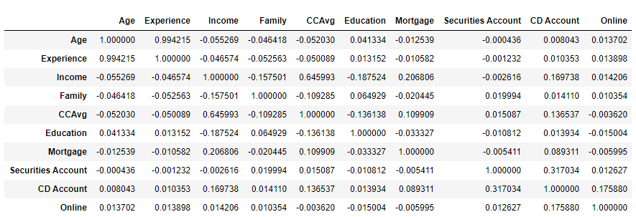

**###### Multicollinearity is test is pass. There is no zero correlation in independent variables.**

**Variable Selection**

#independent and dependent Features

X = dataset1.iloc[:,:-1] # independent Features

y = dataset1.iloc[:,-1] # dependet Feature



**##### For X – Independent Variable are categorical and continues .**



**##### Y is dependent variable is binary Categorical. So those variable selction conditions are satisfied**

import statsmodels.api as sm

X1 = sm.add_constant(X)



**##### To add the constant variable in first columns based on the formula**

Logistic = sm.Logit(y,X1)

result = Logistic.fit()

**##### Logistic Equation p = 1/(1+e** -(B0+B1X1+….+BnXn))**

**##### Logit is function name and y = dependent variable, X1 – independent variable alone with Constant**

result.summary()

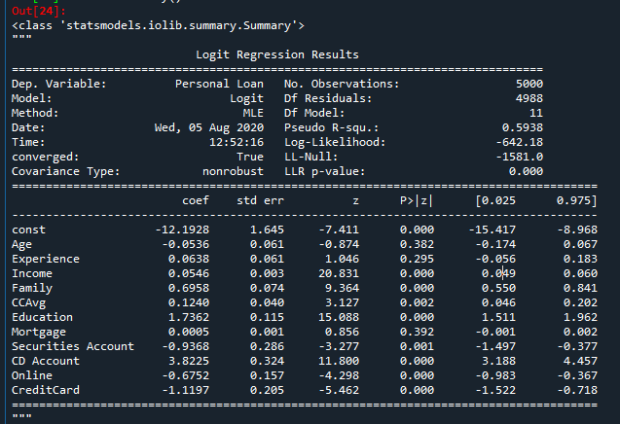

**##### In multiple predictor model contains one dependent Variable and multiple independent variables.**

**Here P values based (p>0.05) Except “Age”,”Experience” and “Mortgage” are greater than 0.05**

**So that remaining “CCAvg”, “Securities Account” are Significantly important for getting ”Personal Loan”**

**Most Significantly important independent Features are “income”,”Family”,”Education”, “CDAccount”,”Online” and “Credit Card”**